**Project Design Phase-I**

**Solution Architecture**

|  |  |
| --- | --- |
| Date | 12 October 2022 |
| Team ID | PNT2022TMID15761 |
| Project Name | SMART FASHION RECOMMENDER APPLICATION |
| Maximum Marks | 4 Marks |

**Solution Architecture:**

We have developed a new innovative solution through which you can directly do your online shopping based on your choice without any search. It can be done by using the chatbot. In this project you will be working on two modules:

* Admin
* User

Instead of searching for products in the search bar and navigating to individual products to find required preferences, this project leverages the use of chatbots to gather all required preferences and recommend products to the user. The solution is implemented in such a way as to improve the interactivity between customers and applications. The chatbot sends messages periodically to notify offers and preferences. For security concerns, this application uses a token to authenticate and authorize users securely. The token has encoded user id and role. Based on the encoded information, access to the resources is restricted to specific users.

**Example - Solution Architecture Diagram:**

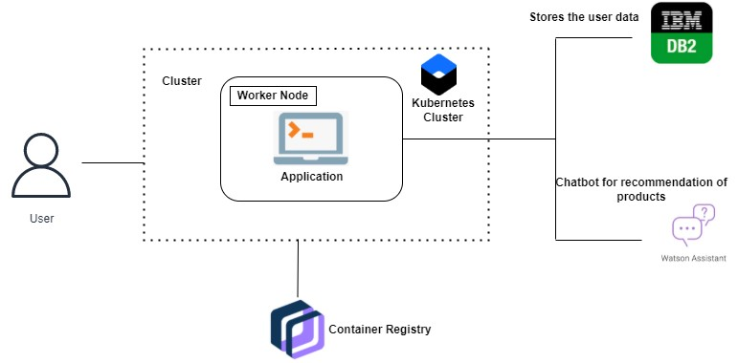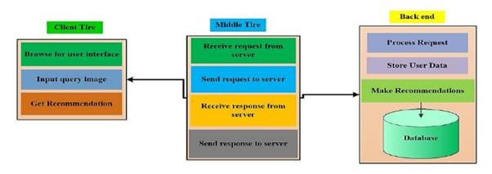

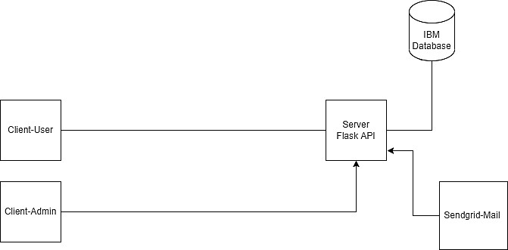

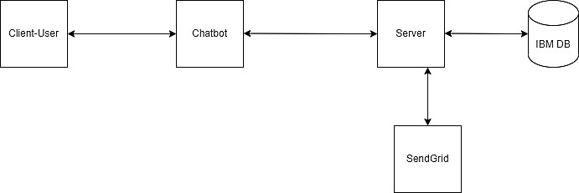

*Figure 1: Architecture and data flow of the smart fashion recommendation system*